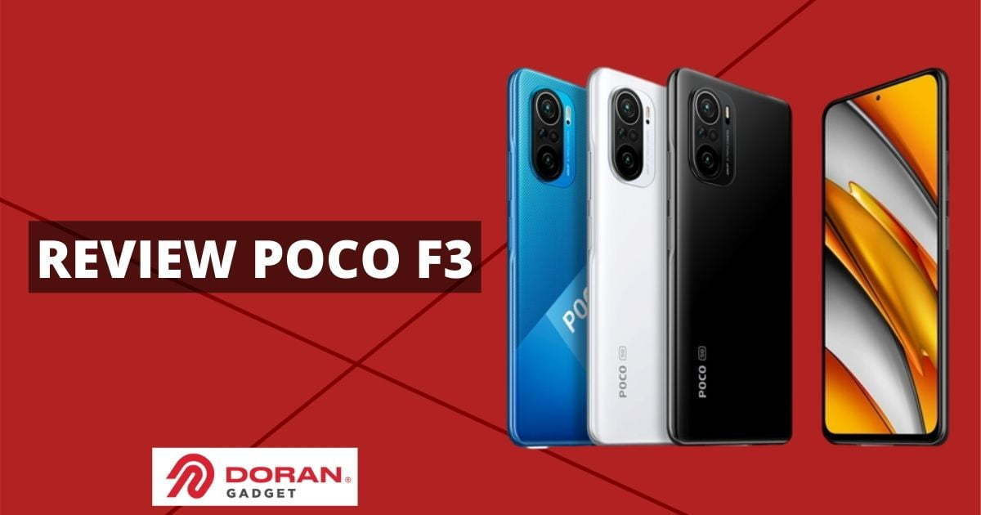

Product Terbaru

Kategori

Contact

Cart (0)

Blog

Product

Beranda

search

Shopee

Log In

Email : amrulloh.opm@gmail.com

Telpon : 087753112196